Assessment 2

Open source & testing A2

Jacob Cerff

Contents

Introduction 1

Working Program Evidence 1

Programming debugging Evidence 4

Standard Sequential Access Algorithm 8

Open Source Supporting Documentation 9

Testing 10

# Introduction

Converter for ATCA Gas,

The project that has been assigned is the ATCA Gas Converter, as ATCA Gas uses require an American standard Metric to confirm measurements, a converter is required that can quickly and easily convert from Australian to American standard and must be accessible from the field.

The Project has a confirmed budget of $20,000 including a negotiable maintenance time of 6 months, any other further time that may be required is also negotiable.

# Working Program Evidence

Screenshot Evidence of working Program, if changes are required refer to the number of specified Screenshot and written change for ease.

Converter WPSS (1)

* All inputs have been entered, include a decimal

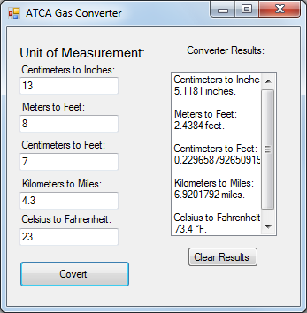

Converter WPSS (2)

* A NaN (not a number) has been entered, error message displayed

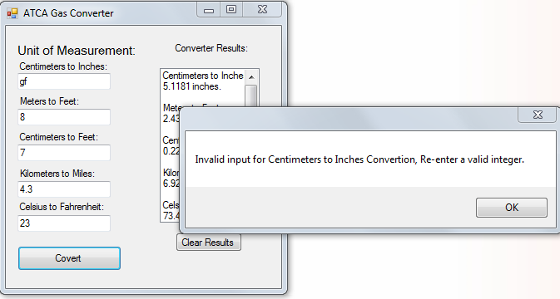

Converter WPSS (3)

* Nothing has been entered, error message displayed

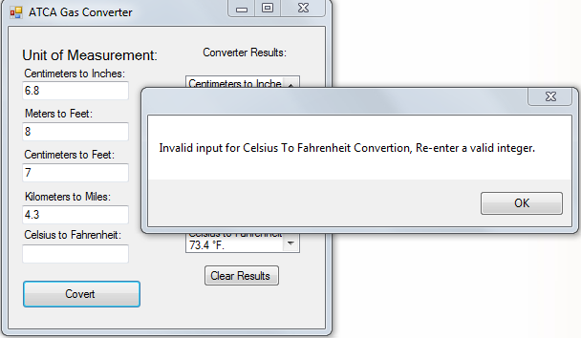

Converter WPSS (4)

* All previous conversions is still displayed

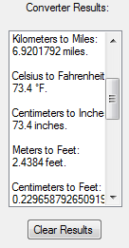

Converter WPSS (5)

* Clear results button working

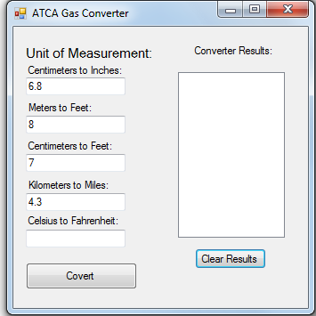

# Programming debugging Evidence

Screenshots of the progression for each stage of the programs development

Converter DSS (1)

* Original design, with one button function working
* Error for input entered also working

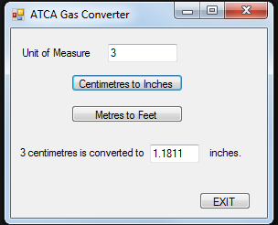

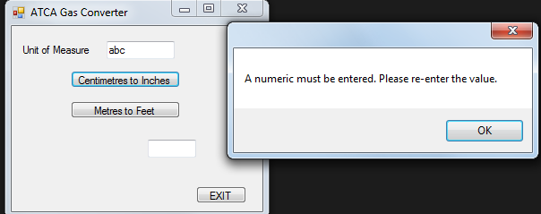

Converter DSS (2)

* Original code, stripped version placed into an array

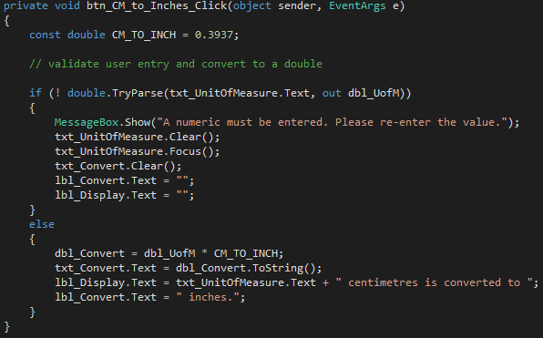

* Array is used and a new function was created

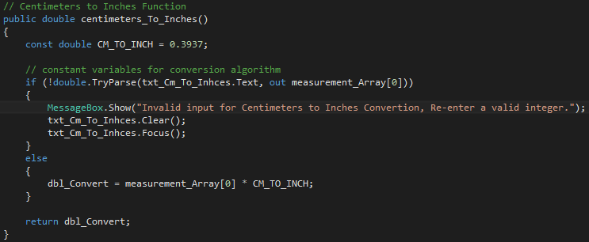

Converter DSS (3)

* Start of new Design progress

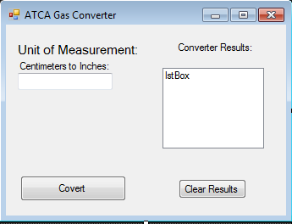

* All Measurements added and ready for code to be implemented
* Final design for program

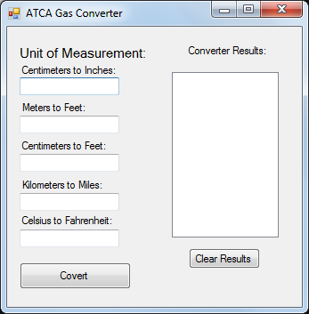

Converter DSS (4)

* Functions with comments have been written

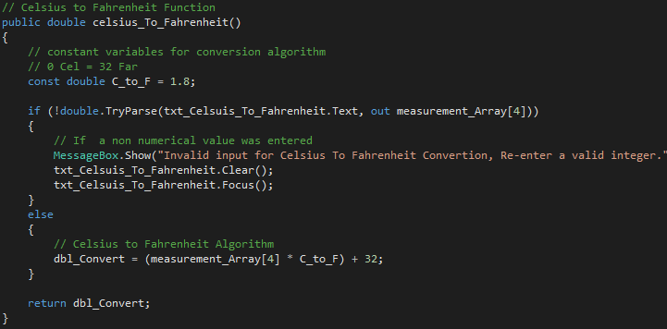

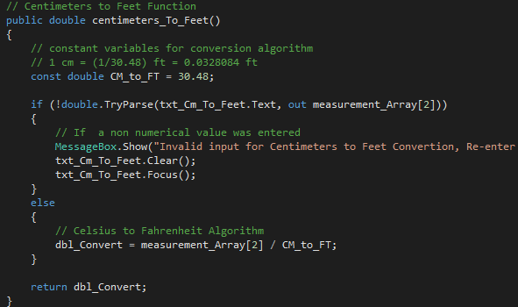

Converter DSS (5)

* Convert Button
* Name error, due to visual studio not being able to update the design name

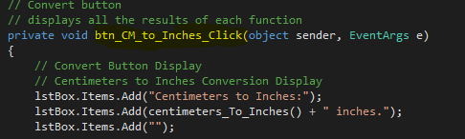

* Actual design name



* Evidence of updated design name in code

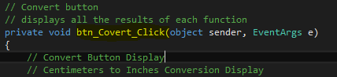

Converter DSS (6)

* Clear Results button code added evidence

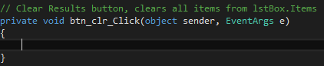

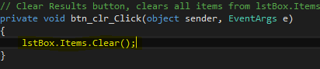

# Standard Sequential Access Algorithm

The arrays that has been chosen is a double as I wanted to use each individual array in the algorithm itself.

In order to achieve this the dbl_UoM initialized double was removed and replaced by an array with no problems.

* Firstly the Array is called “measurement_Array”, and is globally initialized evidence bellow



* Evidence of array inside specific functions

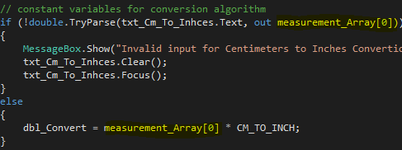

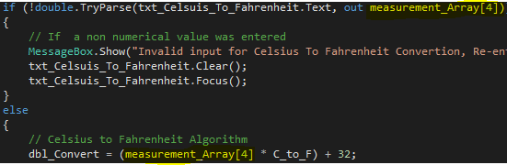

# Open Source Supporting Documentation

Github is the chosen OS system that has been chosen, this was the preferred choice by the user (Gail), but is also recommend for first time users. Github has easy access and tutorials that anyone can follow and understand. For those who want more than the first hello world tutorial have plenty to their disposal with payments being asked.

Evidence of Github merges and project progress is on Github itself, link bellow as required

<https://github.com/JacobCerff/Assessment-2>

Screenshots

# Testing